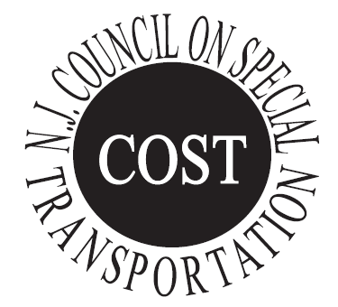
Website: www.njcost.com

New Jersey
Council On Special Transportation
P.O. Box 184, Manville, NJ 08835 Tel (973) 250-9500 Fax (973) 474-2118

County | Phone Number to Make an Appointment | Director
Atlantic County Transportation | (609) 645-5910 | Demitrus Pearson
Bergen County Community Transportation | (201) 368-5955 | Anthony Suarez
Burlington County - Sen-Han Transit | (877) 603-5111 | Chris Smith
Camden County - Sen-Han Transit | (856) 456-3344 | Diane Powell
Cape May County Fare Free Transportation | (609) 889-3700 | Daniel Mulraney
Cumberland Area Transit System CATS | (856) 691-7799 | Theresa Van Sant
Essex County Community Transportation | (973) 737-7200 | Mihcael M. Vieira
Gloucester County Special Transportation | (856) 686-8355 | Lisa Cerny
Hudson County TRANSCEND | (201) 369-4320 | Jimmy Ostaszewski
Hunterdon County Transportation - Link | (800) 842-0531 | Erin Neukum
Mercer County T.R.A.D.E | (609) 530-1971 | Martin DeNero
Middlesex County Area Transit | (800) 221-3520 | Stanley Subjinski
Monmouth County SCAT | (732) 431-6480 | Kathleen Lodato
Morris County Transportation - MAPS | (973) 829-8103 | Christine Hellyer
Ocean County Transportation - Ocean Ride | (877) 929-2082 | David Fitzgerald
Passaic County Paratransit | (973) 305-5756 | John McGill
Salem County Transportation | (856) 339-8644 | Stephanie Bradway
Somerset County Transportation | (908) 231-7115 | John Adair
Sussex County Transportation - Skylands Ride | (973) 579-0480 | Christine Florio
Union County Paratransit | (908) 241-8300 | Solonia Saxton
Warren County Transportation | (866) 594-4044 | JanMarie McDyer
As of July 1, 2020

